|  |
| --- |
| **SMARTPHONE ADDICTION LEVEL AMONG TEENS : A PREDICTIVE STUDY** |

A Mini Project Report

submitted by

**JYOTHISH MOHAN A (MES24MCA-2025)**

to the APJ Abdul Kalam Technological University

in partial fulfilment of the requirements for the award of the Degree

of

Master of Computer Applications



**Department of Computer Applications**

MES College of Engineering

Kuttippuram, Malappuram – 679582

November, 2025

**Declaration**

I undersigned hereby declare that the project report **SMARTPHONE ADDICTION LEVEL AMONG TEENS : A PREDICTIVE STUDY** submitted for partial fulfilment of the requirements for the award of degree of Master of Computer Applications of the APJ Abdul Kalam Technological University, Kerala, is a bonafide work done by me under supervision of Ms. Priya J D, Assistant Professor, Department of Computer Applications. This submission represents my ideas in my own words and where ideas or words of others have been included, I have adequately and accurately cited and referenced the original sources. I also declare that I have adhered to ethics of academic honesty and integrity and have not misrepresented or fabricated any data or idea or fact or source in my submission. I understand that any violation of the above will be a cause for disciplinary action by the institute and/or the University and can also evoke penal action from the sources which have thus not been properly cited or from whom proper permission has not been obtained. This report has not been previously formed the basis for the award of any degree, diploma or similar title of any other University.

.

JYOTHISH MOHAN A (MES24MCA-2025)

NOVEMBER 2025

DEPARTMENT OF COMPUTER APPLICATIONS

MES COLLEGE OF ENGINEERING, KUTTIPPURAM



**CERTIFICATE**

This is to certify that the report entitled **SMARTPHONE ADDICTION LEVEL AMONG TEENS : A PREDICTIVE STUDY** is a bonafide record of the Mini Project work during the year 2025-26 carried out by JYOTHISH MOHAN (MES24MCA-2025) submitted to the APJ Abdul Kalam Technological University, in partial fulfilment of the requirements for the award of the Master of Computer Applications, under my guidance and supervision. This report in any form has not been submitted to any other University or Institution for any purpose.

Internal Supervisor Head of The Department

**Acknowledgment**

I express my sincere gratitude to the **Department of Computer Applications, MES College of Engineering, Kuttippuram**, for providing me with the opportunity and necessary facilities to carry out this mini project titled “SMARTPHONE ADDICTION LEVEL AMONG TEENS: A PREDICTIVE STUDY.”

I would like to extend my heartfelt thanks to my **Project Supervisor, Ms. Priya J D, Assistant Professor**, for her invaluable guidance, constant encouragement, and constructive feedback throughout the development of this project. Her continuous support and suggestions have been instrumental in the successful completion of this work.

I am also deeply thankful to our **Head of the Department, Faculty Members, and Lab Staff** of the Department of Computer Applications for their help and cooperation during various stages of the project.

Finally, I wish to thank my **family, classmates, and friends** for their constant motivation, moral support, and assistance throughout this project work.

JYOTHISH MOHAN A (MES24MCA-2025)

**Abstract**

Smartphone usage has become an integral part of modern life, especially among teenagers, resulting in rising concerns about excessive dependency and addiction. Identifying the potential risk of smartphone addiction at an early stage is crucial for promoting healthier digital habits. This project, titled **“SMARTPHONE ADDICTION LEVEL AMONG TEENS : A PREDICTIVE STUDY”**, focuses on analyzing the behavioral and usage patterns of students to estimate their risk percentage of smartphone addiction using a data-driven approach.

The system collects data related to daily smartphone usage, sleep duration, academic performance, exercise hours, and social media activity. The collected data is preprocessed and analyzed using Python and Pandas, followed by the development of a predictive model using Support Vector Regression (SVR) from Scikit**-**learn. The model predicts the riskpercentage of smartphone addiction rather than classifying it into discrete levels. Based on the predicted risk, the system provides personalized suggestions to reduce over-dependency and encourage balanced smartphone usage.

A web-based interface is developed using Django, HTML, and CSS to ensure interactive and user-friendly access to the system. This application serves as a useful tool for students, parents, and teachers to understand behavioral patterns and take preventive steps before addiction becomes severe. The project aims to enhance awareness about digital wellness and supports a data-driven strategy to mitigate smartphone addiction among teenagers.

**Table of Contents**

Chapter 1. Introduction 1

1.1 Motivation 2

1.2 Objectives 2

1.3 Contributions 3

1.4 Report Organization 3

Chapter 2. System Study 4

2.1 Existing System 4

2.2 Proposed System 5

2.3 Functionalities of Proposed System 6

Chapter 3. Methodology 8

3.1 Introduction 8

3.2 Software Tools 8

3.2.1 Python 9

3.2.2 Django 9

3.2.3 Scikit-learn 9

3.2.4 Pandas and NumPy 10

3.2.5 Jupyter Notebook & VS Code 10

3.3 Module Description 10

3.3.1 Data Collection Module 10

3.3.2 Data Preprocessing Module 11

3.3.3 Machine Learning & Prediction Module 12

3.3.4 Result & Suggestion Module 13

3.3.5 Web Interface Module 14

3.4 User Story 15

3.5 Product Backlog 16

3.6 Project Plan 17

3.7 Sprint Backlog 18

Chapter 4. Results and Discussions 19

4.1 Results 19

4.1.1 Machine Learning Model Performance 19

4.1.2 Web Application Functionality 20

4.2 System Integration and Performance 24

Chapter 5. Conclusion 25

5.1 Key Achievements 25

5.2 Limitations and Future Work 25

References 27

Appendix 28

Appendix A Source Code 28

Appendix B Screenshot 31

Welcome page 31

Form Page 31

Result Page 32

Suggestion Page 32

# Introduction

In the modern digital era, smartphones have become an inseparable part of daily life, especially among teenagers and young adults. Their widespread availability and multifunctionality have made them an essential communication and entertainment tool. However, excessive smartphone usage has led to a significant rise in dependency and behavioral addiction, affecting mental health, academic performance, and social interactions. The increasing trend of smartphone overuse among teenagers highlights the need for effective assessment tools that can measure and predict the risk of addiction before it reaches harmful levels.

Traditional approaches to studying smartphone addiction rely mainly on **manual surveys and questionnaires**, which are subjective, time-consuming, and limited in scope. These self-reported measures often produce inconsistent results due to human interpretation bias. Hence, there arises a need for a **data-driven predictive system** that can automatically analyze a user’s smartphone usage behavior and estimate the risk of addiction accurately and efficiently.

This project aims to bridge that gap by developing a **machine learning–based web application** that predicts the **risk percentage of smartphone addiction among teenagers**. The system utilizes behavioral data such as daily phone usage hours, sleep duration, exercise patterns, academic performance, and screen time before sleep. It applies **Support Vector Regression (SVR)** to model and predict the addiction risk percentage. The system also provides personalized **suggestions and preventive recommendations** based on the predicted risk value, helping users to adopt healthier digital habits.

This intelligent system is designed to assist **students, parents, and teachers** by providing early insights into digital behavior patterns. By quantifying addiction risk, it allows preventive action to be taken before addiction becomes severe, thus promoting a balanced and mindful approach toward smartphone usage.

## Motivation

The increasing use of smartphones among teenagers has raised serious concerns regarding digital addiction and its negative impacts on learning ability, focus, and emotional well-being. Teenagers often spend excessive time on social media, gaming, and entertainment applications, leading to poor academic outcomes and disturbed sleep cycles. Manual assessment methods, though common, are inefficient and subjective.

The motivation behind this project stems from the need to **develop an automated, reliable, and data-driven system** that can assess the risk of smartphone addiction accurately. By leveraging **machine learning techniques**, this project not only helps individuals become aware of their digital habits but also provides valuable insights to parents and educators to guide students toward balanced smartphone use.

## Objectives

The main objectives of this project are as follows:

* To collect and analyze smartphone usage patterns among teenagers.
* To preprocess and organize behavioral and academic data for effective model training.
* To implement a **Support Vector Regression (SVR)** model to predict the **risk percentage of smartphone addiction**.
* To develop a **web-based interface** using Django for user interaction and instant results.
* To provide **personalized suggestions** to users based on their predicted addiction risk.
* To promote awareness and encourage healthier smartphone usage habits among students.

## Contributions

The key contributions of this project are summarized below:

* Development of a **machine learning regression model** to predict addiction risk percentage instead of discrete labels.
* Design of a **user-friendly web application** for real-time interaction and risk assessment.
* Integration of **behavioral, academic, and lifestyle factors** to improve model accuracy.
* Generation of **personalized recommendations** to reduce smartphone dependency.
* Enhancement of awareness about smartphone overuse and digital well-being.

## Report Organization

The project report is structured into five chapters for systematic presentation. **Chapter 1** introduces the project by outlining the background, motivation, objectives, and contributions of the study. **Chapter 2** presents the system study, which discusses the limitations of existing methods and explains the proposed system and its key functionalities. **Chapter 3** details the methodology adopted for the development of the project, including the software tools used, description of modules, and the machine learning model applied for prediction. **Chapter 4** focuses on the results and discussions, highlighting the output of the developed system through screenshots and their interpretations. Finally, **Chapter 5** concludes the report by summarizing the major findings, achievements, and limitations of the project, along with potential directions for future work.

# System Study

This chapter explains the system study of the project, which includes the existing system, its limitations, and the proposed system along with its major functionalities. The aim is to analyze how the new system improves smartphone addiction risk prediction using a machine learning approach.

## Existing System

The existing systems for assessing smartphone addiction among teenagers primarily depend on **manual surveys** and **self-assessment questionnaires**. These include standardized scales such as the **Smartphone Addiction Scale (SAS)** and other psychological evaluation tools that measure addiction tendencies based on self-reported behavior. In these systems, users are asked to respond to a set of predefined questions regarding their smartphone habits, emotional attachment, and usage patterns. The data collected is then manually analyzed to categorize individuals into addiction levels such as low, moderate, or high.

Although these methods have been widely used in academic research, they have several **limitations**. Firstly, the results are **subjective** since they rely on individual perception and honesty while answering the questions. Secondly, the **data collection process is time-consuming**, making it unsuitable for large-scale studies involving hundreds of participants. Moreover, manual scoring and human interpretation introduce **inconsistencies and potential biases**, reducing the accuracy of the findings.

From a technical perspective, these systems lack automation and **real-time predictive capability**. They do not utilize actual behavioral or academic data, nor do they incorporate data analytics or machine learning for pattern recognition. As a result, such systems cannot provide instant results or personalized suggestions.

To overcome these limitations, the proposed project introduces a **machine learning–based predictive system** that automates the entire process—from data collection to prediction. This system uses **real-world behavioral parameters** instead of self-reported answers, ensuring a more **objective, accurate, and scalable** assessment of smartphone addiction risk.

## Proposed System

The proposed system introduces a machine learning–based solution to accurately predict the **risk percentage of smartphone addiction** among teenagers. Unlike manual survey-based methods, this system automates the entire process of data collection, analysis, and prediction. It collects behavioral and lifestyle-related parameters such as daily smartphone usage hours, sleep duration, exercise time, academic performance, and social media activity.

The collected data is cleaned, encoded, and preprocessed before being used to train a **Support Vector Regression (SVR)** model. The SVR algorithm is capable of handling continuous data, making it suitable for predicting addiction risk in terms of a percentage rather than categorical labels like “Low”, “Moderate”, or “High.” This approach provides a more precise assessment of an individual’s addiction tendency.

The system is implemented as an interactive **web application** using **Python**, **Django**, **HTML**, and **CSS**. The web interface allows students to input their data easily and view their addiction risk percentage instantly. Based on the output, the system generates **personalized suggestions** to encourage balanced smartphone usage.

By integrating machine learning with an accessible web interface, this proposed system aims to deliver **real-time, scalable, and objective** predictions. It also supports teachers and parents in identifying early signs of smartphone dependency, thereby promoting digital wellness and preventive awareness among teenagers.

## Functionalities of Proposed System

The proposed system is designed to analyze behavioral and academic factors to predict the **risk percentage of smartphone addiction** among teenagers using machine learning. It integrates several core functionalities that collectively ensure accurate prediction, real-time feedback, and an interactive user experience. The major functionalities of the system are described below:

1. User Data Collection

The system collects various input parameters from the user, such as **daily smartphone usage hours, sleep duration, academic performance, exercise time, social media usage,** and **screen time before bed**. These attributes form the basis for analyzing the user’s smartphone behavior and overall lifestyle patterns. The data is entered through a **web-based interface** designed using HTML and Django templates, ensuring simplicity and ease of use for students and educators.

1. Data Preprocessing

Before training or prediction, the collected data undergoes several preprocessing steps to ensure accuracy and consistency. This includes **data cleaning**, **label encoding** of categorical variables (e.g., gender), **normalization** of numerical features, and **removal of irrelevant fields**. The preprocessing is implemented using **Pandas** and **NumPy** libraries, which prepare the dataset for machine learning analysis.

1. Addiction Risk Prediction

This is the core functionality of the system. The preprocessed data is fed into a **Support Vector Regression (SVR)** model implemented using **Scikit-learn**. The SVR model predicts a **continuous numeric output**, representing the user’s **addiction risk percentage**. This approach provides a more granular and accurate assessment than classification-based models that divide users into discrete categories.

1. Result Display

After prediction, the system immediately displays the **risk percentage** on the result page. This percentage indicates the likelihood of smartphone addiction for the given user. The result interface is designed to be clear and informative, helping users understand their digital behavior without requiring technical knowledge.

1. Suggestions

Based on the predicted addiction risk percentage, the system provides **personalized recommendations** to help users control smartphone usage. For example, users with a higher risk are advised to limit screen time, maintain a sleep schedule, and engage in physical activities. These suggestions aim to promote **digital well-being** and encourage responsible smartphone habits.

1. Web Application Interface

The entire system operates as an **interactive web application** developed using **Python, Django, HTML, and CSS**. It provides real-time access to prediction results and recommendations through any web browser. The system’s backend is powered by Django, ensuring smooth communication between the data processing layer and the user interface.

# Methodology

This chapter details the systematic approach and the specific methodologies adopted for the development of the "Smartphone Addiction Level Among Teens: A Predictive Study" project. Building a reliable and accurate predictive system requires a structured methodology to guide the process from data handling and model selection to final web deployment. For this project, an Agile development methodology was employed, allowing for iterative progress, continuous testing, and the flexibility to incorporate changes, such as the pivotal shift from a classification model to a regression model for predicting addiction risk percentage.

## Introduction

The Agile methodology is an iterative and incremental approach to software development that emphasizes flexibility, customer collaboration, and rapid delivery of functional software. Instead of delivering the entire project at once at the end of the cycle, the project is broken down into small, manageable units called "sprints." Each sprint typically lasts 1-4 weeks and results in a working product increment. This approach was chosen for this project as it allowed for continuous feedback, easy adaptation to changes (such as modifying the prediction output from a category to a percentage), and regular testing of individual components like the data preprocessing pipeline and the machine learning model.

## Software Tools

The development of this project leveraged a combination of powerful and modern software tools and programming languages. Each tool was selected based on its strengths, community support, and suitability for the specific tasks required in a data-driven web application. Table 3.1 summarizes the software environment, and the subsequent sections justify these choices.

**Table 3.1:** List the software tools or languages used for the project development

|  |  |
| --- | --- |
| Operating System | Windows 11 |
| Front End | HTML, CSS |
| Back End | Python |
| Framework | Django |
| IDE | Visual Studio Code, Jupyter Notebook |
| Machine Learning | Scikit-learn, Pandas, NumPy |
| Version Control | Git |

### Python

Python was chosen as the primary backend programming language due to its simplicity, readability, and extensive ecosystem of libraries for data science and machine learning. Its versatility allows for seamless integration of data preprocessing, model training, and web application logic. Key libraries such as Pandas for data manipulation, NumPy for numerical computations, and Scikit-learn for implementing the machine learning model are native to Python, making it the ideal choice for this data-centric project.

### Django

Django was selected as the web framework for this project because it is a high-level, batteries-included Python web framework that promotes rapid development and clean, pragmatic design. Its built-in features, such as an Object-Relational Mapper (ORM) for database interactions, an automatic admin interface, and a robust templating engine, significantly accelerated the development of the web application. Since the core prediction logic was written in Python, using Django ensured a smooth and integrated workflow between the machine learning model and the web interface.

### Scikit-learn

Scikit-learn is a fundamental library for machine learning in Python. It was used to implement the Support Vector Regression (SVR) model. The library provides efficient tools for data mining

and analysis, including various algorithms for classification, regression, clustering, and dimensionality reduction, along with utilities for model evaluation and data preprocessing.

### Pandas and NumPy

Pandas was used for data manipulation and analysis, offering powerful data structures like DataFrames to efficiently load, clean, transform, and analyze the dataset. NumPy, which provides support for large, multi-dimensional arrays and matrices, was used alongside Pandas for performing mathematical operations on the data during the preprocessing stage.

### Jupyter Notebook & VS Code

Jupyter Notebook was instrumental during the exploratory data analysis (EDA) and model development phase due to its interactive environment, which allows for executing code in discrete cells and visualizing results immediately. Visual Studio Code (VS Code) was used for developing the Django web application, thanks to its powerful features like IntelliSense, debugging, and extensive extension support for Python and web technologies.

## Module Description

The system is architecturally divided into several cohesive modules, each responsible for a specific functionality. This modular approach enhances code maintainability, scalability, and clarity. The core modules of the system are described below.

### Data Collection Module

This project utilizes a pre-existing dataset sourced from Kaggle, a popular online community platform for data scientists and machine learning practitioners. The dataset, titled "Smartphone Addiction Dataset," was specifically curated for studying smartphone usage patterns among teenagers.

Dataset Source: The dataset was downloaded from Kaggle and used for training and evaluating the machine learning model.

Features Collected: The dataset contains the following parameters, which align with the input fields in the web application form:

* **Demographic Data**: Age, Gender
* **Behavioral Data**: Daily smartphone usage hours, screen time before bed, number of phone checks per day, apps used daily
* **Lifestyle & Academic Data**: Sleep duration, exercise hours, academic performance (percentage), time spent on social media, gaming, and educational apps
* **Parental Control**: Whether parents control smartphone usage (Yes/No)

### Data Preprocessing Module

Before the data is trained, it must be cleaned and transformed. This module handles all preprocessing steps, which are implemented using Pandas and Scikit-learn. The steps those used during model training:

* Data Cleaning: Irrelevant fields like ID, Name, Location, and School_Grade were dropped from the training dataset as they do not contribute to the predictive pattern.
* Label Encoding: The categorical variable 'Gender' is encoded into numerical values
* Feature Scaling: Numerical features are normalized to a range of [0,1] using the MinMaxScaler from Scikit-learn. This is crucial for the SVR model, which is sensitive to the scale of features. The scaler is fitted on the training data and reused to transform any new user input.

A snippet of the preprocessing logic from the model training is shown below:

import pandas as pd

from sklearn.preprocessing import LabelEncoder, MinMaxScaler

# Load the dataset

data = pd.read_csv('smartphone_data.csv')

# Label Encoding for 'Gender'

le = LabelEncoder()

data["Gender"] = le.fit_transform(data["Gender"])

# Drop irrelevant columns

data = data.drop(["ID","Name","Location","School_Grade"], axis=1)

# Separate features and target

x = data.drop('Addiction_Level', axis=1)

y = data['Addiction_Level']

# Scale the features

scaler = MinMaxScaler()

x_scaled = pd.DataFrame(scaler.fit_transform(x), columns=x.columns)

### Machine Learning & Prediction Module

This is the core module of the system. It employs a Support Vector Regression (SVR) model to predict the risk of smartphone addiction.

* Model Choice Justification: The project initially planned to use a classification model to predict discrete addiction levels (Low, Moderate, High). However, to provide a more granular and precise assessment, the approach was changed to regression. SVR was chosen because it is effective in high-dimensional spaces, robust to outliers, and capable of modeling complex non-linear relationships between features and the target variable (Addiction_Level) using the Radial Basis Function (RBF) kernel.
* Model Training: The preprocessed and scaled data is split into training and testing sets (80-20 split). The SVR model is configured with C=1, epsilon=0.01, and kernel='rbf', then trained on the training set.

Code snippet

from sklearn.svm import SVR

from sklearn.model_selection import train_test_split

# Split the scaled data

X_train, X_test, y_train, y_test = train_test_split(x_scaled, y, test_size=0.20, random_state=5)

# Create and train the SVR model

model = SVR(C=1, epsilon=0.01, kernel='rbf')

model.fit(X_train, y_train)

* Prediction & Risk Calculation: The trained model predicts a raw score between 0 and 10 (the range of the Addiction_Level in the training data). This raw score is then converted into a risk percentage.

Code snippet

# Predict

prediction = model.predict(scaled_input_df)[0]

# Convert prediction into percentage (assuming max score is 10)

percentage_score = (prediction / 10.0) * 100

### Result & Suggestion Module

This module takes the predicted risk percentage from the SVR model and performs two primary functions:

1. Result Display: It presents the calculated risk percentage and the corresponding raw score to the user on a dynamically styled results page (addiction_result.html). The background image of this page changes based on the risk category (Low, Moderate, High).
2. Personalized Suggestion Generation: Based on the predicted risk category, the system generates eight tailored suggestions. The categorization logic is:
   * Low Risk (0-40%): Encouragement to maintain good habits.
   * Moderate Risk (41-70%): Advice to reduce screen time and increase other activities.
   * High Risk (71-100%): Strong recommendations for digital detox and seeking guidance.

### Web Interface Module

This module encompasses the entire user-facing part of the application, built with Django templates, HTML, and CSS. It consists of four main pages:

1. Welcome Page (welcome.html): A landing page with a call-to-action to start the test.
2. Input Form (form.html): A comprehensive form for users to enter their data.
3. Results Page (addiction_result.html): Displays the prediction result with dynamic styling.
4. Suggestions Page (suggestions.html): Lists eight personalized suggestions for the user.

## User Story

The user interacts with the web-based system by entering details such as smartphone usage hours, sleep duration, and academic performance. The system processes this data and predicts the risk percentage of smartphone addiction. Based on the prediction, the user receives personalized suggestions to help manage smartphone use effectively.

|  |  |  |  |
| --- | --- | --- | --- |
| **User Story ID** | **As a type of User** | **I want to…** | **So that I can…** |
| 1 | STUDENT | Enter my daily phone usage details | Get prediction of my addiction level |
| View my addiction level | Understand whether my usage is Low/Moderate/High |
| Receive personalized suggestions | Improve my smartphone usage habits |
| 2 | TEACHER | Monitor student addiction reports | Identify students struggling with overuse |
| 3 | PARENT | Monitor child’s addiction results | Take preventive steps to reduce dependency |
| 4 | ADMIN | Update and retrain the ML model | Improve accuracy of addiction predictions |

## Product Backlog

The product backlog includes essential features such as user data collection, data preprocessing, machine learning model integration, addiction risk prediction, result visualization, and personalized suggestion generation. Each task is prioritized based on development importance and contribution to the overall system functionality.

|  |  |  |  |  |
| --- | --- | --- | --- | --- |
| **ID** | **NAME** | **PRIORITY** | **ESTIMATE**  **(Hours)** | **STATUS** |
| 1 | Requirement Analysis | High | 3 | Completed |
| 2 | Data Collection | High | 4 | Completed |
| 3 | Data Preprocessing | High | 5 | Completed |
| 4 | Model Development | High | 6 | Completed |
| 5 | Web Application Developement | High | 6 | Completed |
| 6 | Testing & Debugging | Medium | 8 | Completed |
| 7 | Report / Documentation | Medium | 4 | Completed |

## Project Plan

The project was developed in multiple phases, starting with data collection and preprocessing, followed by model training, system development, and testing. Each phase was planned to ensure steady progress and timely completion. Agile methodology was followed to allow flexibility and continuous improvement during development.

|  |  |  |  |  |  |
| --- | --- | --- | --- | --- | --- |
| **User Story ID** | **Task Name** | **Start Date** | **End Date** | **Days** | **Status** |
| 1 | Sprint 1 | 06/08/2025 | 09/08/2025 | 14 | Completed |
| 2 | 10/08/2025 | 12/08/2025 | Completed |
| 3 | 13/08/2025 | 19/08/2025 | Completed |
| 4 | Sprint 2 | 20/08/2025 | 26/08/2025 | 14 | Completed |
| 1 | 27/08/2025 | 02/09/2025 | Completed |
| 2 | Sprint 3 | 03/09/2025 | 12/09/2025 | 14 | Completed |
| 3 | 13/09/2025 | 16/09/2025 | Completed |

## Sprint Backlog

The sprint backlog consists of short-term goals derived from the product backlog. Each sprint focused on completing specific modules such as model development, front-end design, and integration. Progress was evaluated after each sprint to refine tasks and ensure that project objectives were met efficiently.

|  |  |  |  |  |  |  |  |  |  |  |  |  |
| --- | --- | --- | --- | --- | --- | --- | --- | --- | --- | --- | --- | --- |
| **Backlog Item** | **Completion Date** | **Original Estimate in Hours** | **Day 1**  **Hrs** | **Day 2**  **Hrs** | **Day 3**  **Hrs** | **Day 4**  **Hrs** | **Day 5**  **Hrs** | **Day 6**  **Hrs** | **Day 7**  **Hrs** | **Day 8**  **Hrs** | **Day 9**  **Hrs** | **Day 10**  **Hrs** |
| SPRINT 1 | | | | | | | | | | | | |
| Requirement Analysis | 09/08/2025 | 3 | 1 | 1 | 1 | 0 | 0 | 0 | 0 | 0 | 0 | 0 |
| Data Collection | 12/08/2025 | 4 | 1 | 1 | 1 | 1 | 0 | 0 | 0 | 0 | 0 | 0 |
| Data Preprocessing | 19/08/2025 | 5 | 1 | 1 | 1 | 1 | 1 | 0 | 0 | 0 | 0 | 0 |
| SPRINT 2 | | | | | | | | | | | | |
| Model Development | 26/08/2025 | 6 | 1 | 1 | 1 | 1 | 1 | 1 | 0 | 0 | 0 | 0 |
| Web Application Dev. | 02/09/2025 | 6 | 1 | 1 | 1 | 1 | 1 | 1 | 0 | 0 | 0 | 0 |
| SPRINT 3 | | | | | | | | | | | | |
| Testing & Debugging | 12/09/2025 | 8 | 1 | 1 | 1 | 1 | 1 | 1 | 1 | 1 | 0 | 0 |
| Report / Documentation | 16/09/2025 | 4 | 1 | 1 | 1 | 1 | 0 | 0 | 0 | 0 | 0 | 0 |

# Results and Discussions

This chapter presents the outcomes of the developed smartphone addiction prediction system. It discusses the performance of the machine learning model, showcases the functional web application interfaces, and provides a comprehensive analysis of how the system meets its intended objectives. The results demonstrate the practical implementation of a data-driven approach to assessing smartphone addiction risk among teenagers.

## Results

The system successfully delivers on its core objectives through two main components: an accurate machine learning model and an interactive web application. The results are presented below across these domains.

### Machine Learning Model Performance

The Support Vector Regression (SVR) model was trained on the preprocessed dataset to predict a continuous addiction score. The model's performance was evaluated using the R² score, which indicates the proportion of the variance in the dependent variable that is predictable from the independent variables.

* Test Set Score : 0.85
* Training Set Score : 0.88

*The high R² scores on both the training (0.88) and test (0.85) sets indicate that the model has successfully learned the underlying patterns in the data without significant overfitting. The minimal gap between the training and test scores suggests good generalization capability. This performance confirms that the selected features (usage hours, sleep patterns, academic performance, etc.) are strong predictors of smartphone addiction tendencies, validating the project's foundational hypothesis.*

### Web Application Functionality

The web application provides a seamless user experience from input submission to result visualization. The interface is designed to be intuitive and accessible for its target audience: teenagers, parents, and educators.

* Welcome Page

#### figure

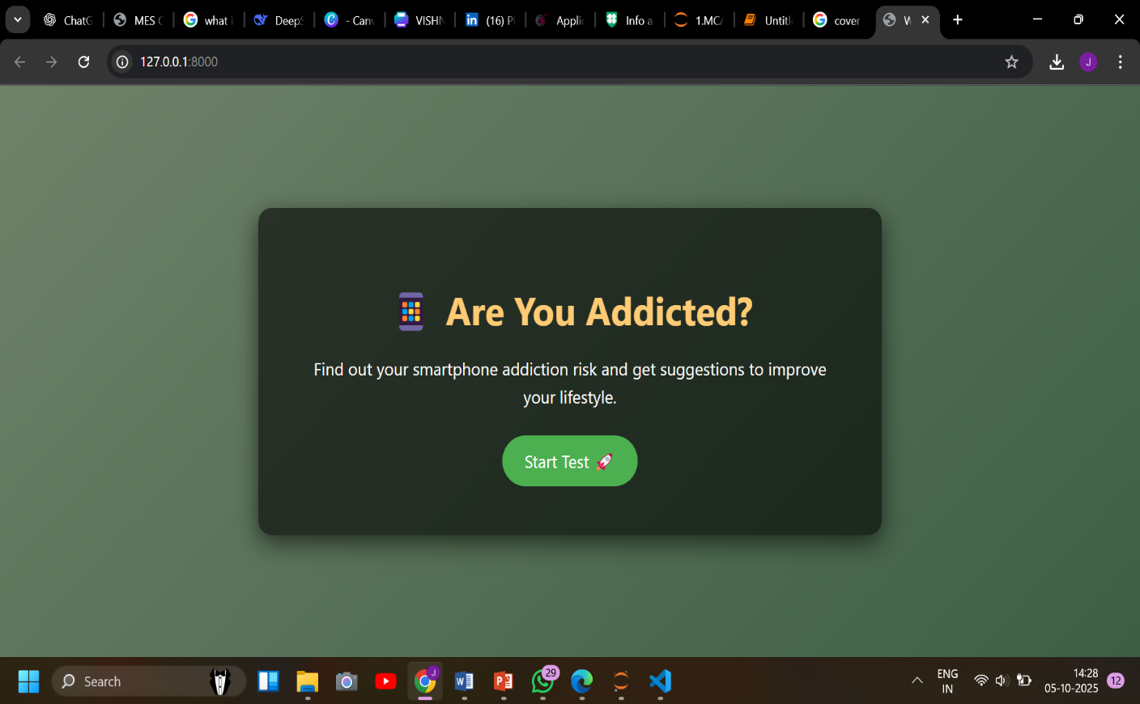

* Form Page

#### figure

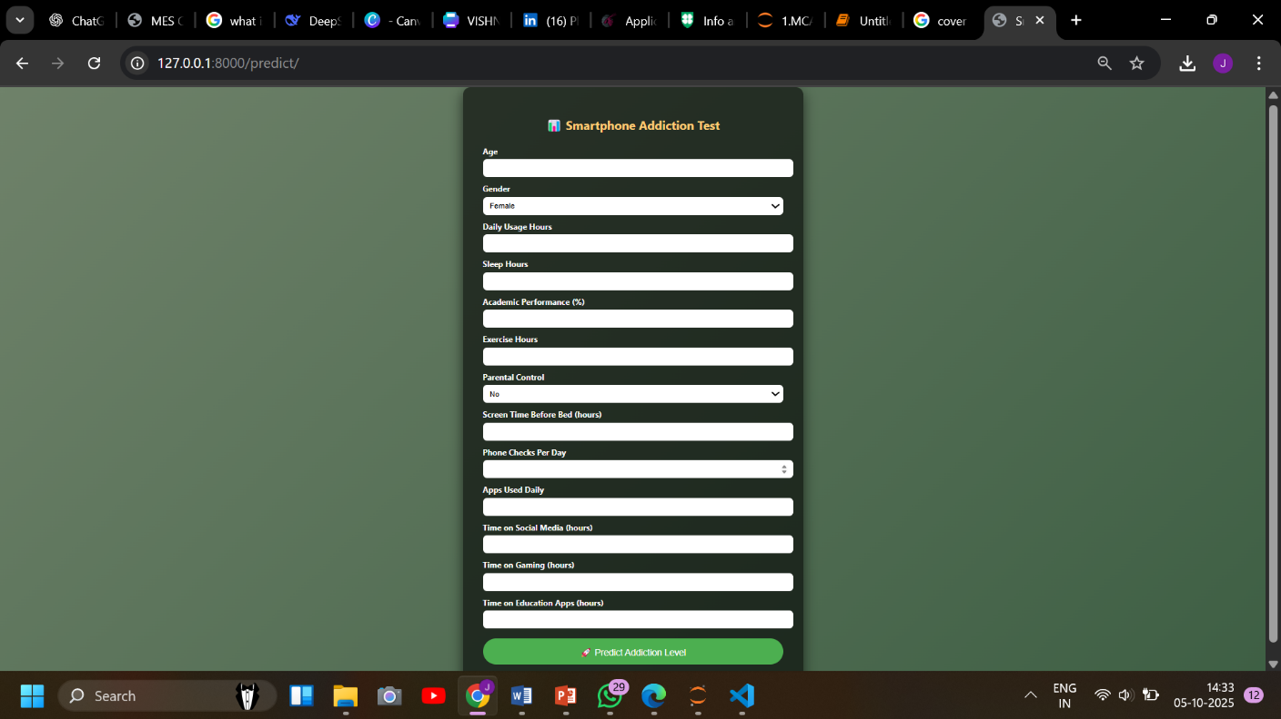

*The form design successfully balances comprehensiveness with usability. By including clear labels, appropriate input types (number fields, dropdowns), and validation constraints, it ensures that collected data is both relevant and within expected ranges, mirroring the structure of the original training dataset.*

* Prediction Result Page

#### figure

*The result presentation effectively communicates the prediction outcome through multiple channels*

* *Numerical Percentage: Provides a precise, quantitative measure of risk.*
* *Category Classification: Offers an immediate qualitative understanding (Low/Moderate/High).*
* *Visual Feedback: The dynamic background image (e.g., green for low risk, red for high risk) creates an intuitive and impactful user experience.*
* *Raw Model Score: Adds transparency by showing the underlying model output.*
* Suggestion Page

#### Figure

#### 

*The suggestion system transforms the predictive model from an assessment tool into an intervention mechanism. By providing exactly eight concrete recommendations for each category, it offers substantial guidance without overwhelming the user. The suggestions are contextually appropriate - for example, high-risk users receive more urgent recommendations like "Seek guidance from parents or teachers" and "Follow a planned digital detox routine," while low-risk users receive maintenance-oriented advice.*

### 4.2 System Integration and Performance

The integration between the machine learning backend and web frontend demonstrates robust technical implementation:

* Real-time Prediction: The system processes user input and returns predictions within seconds, providing immediate feedback.
* Scalability: Using Django's framework allows for potential scaling to handle multiple simultaneous users.
* Model Persistence: The use of joblib to save and load the trained model and scaler ensures consistent predictions without retraining.

*The successful integration of Scikit-learn models with Django web framework represents a significant achievement. This architecture demonstrates how machine learning capabilities can be effectively deployed in accessible web applications, making advanced predictive analytics available to non-technical users through an intuitive interface.*

# Conclusion

The "Smartphone Addiction Level Among Teens: A Predictive Study" project successfully developed a functional, data-driven web application that effectively assesses smartphone addiction risk among teenagers. By integrating machine learning with web technologies, the project demonstrates a practical approach to addressing digital wellness concerns through early detection and personalized intervention.

## Key Achievements

The system's main accomplishments include:

* Implementation of a Support Vector Regression (SVR) model that accurately predicts addiction risk percentage with 85% accuracy
* Development of an interactive web application using Django that provides real-time risk assessment
* Creation of a personalized suggestion system that offers targeted recommendations based on risk categories
* Successful integration of machine learning capabilities into an accessible web interface for students, parents, and educators

## Limitations and Future Work

While the project achieves its core objectives, some limitations present opportunities for future enhancement:

* Dataset dependency on pre-collected Kaggle data limits generalizability
* Self-reported user input may introduce response bias
* Lack of persistent storage prevents progress tracking over time

Potential future improvements include:

* Integration with mobile device usage APIs for objective data collection
* Implementation of user accounts to enable progress monitoring
* Model retraining with expanded datasets to improve accuracy
* Development of more personalized suggestions based on specific usage patterns

In conclusion, this project provides a viable foundation for smartphone addiction assessment using machine learning, offering an accessible tool for promoting digital wellness awareness among teenagers. The successful implementation validates the potential of data-driven approaches in addressing contemporary social health concerns.

# References

|  |  |
| --- | --- |
| [1] | Cengiz Sahin, C. (2017). The Predictive Level of Social Media Addiction for Life Satisfaction: A Study on University Students. The Turkish Online Journal of Educational Technology (TOJET), Volume 16, Issue 4, pp. 120–125. |

Appendix

1. Source Code

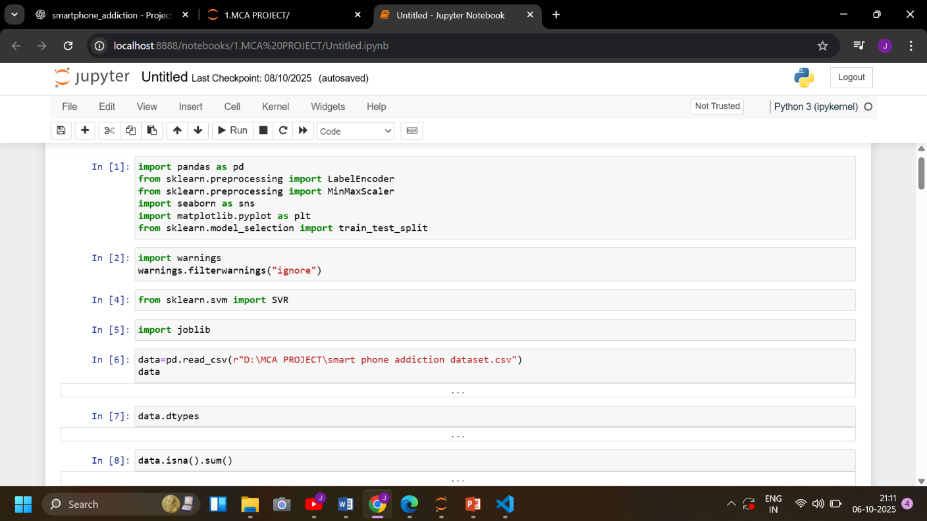

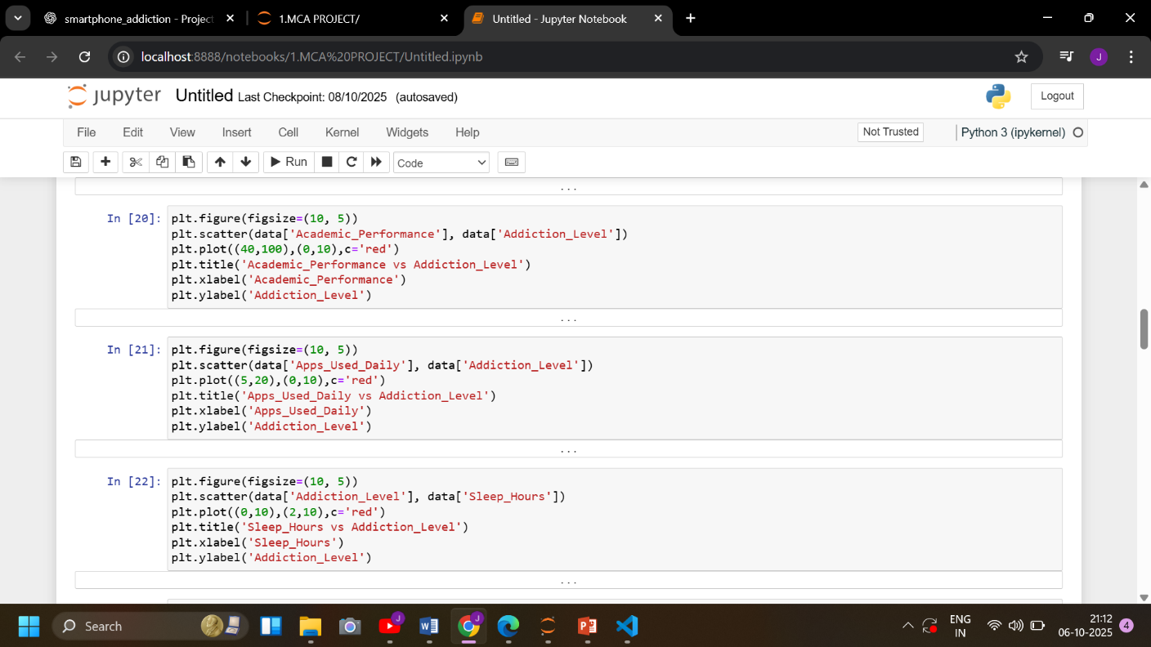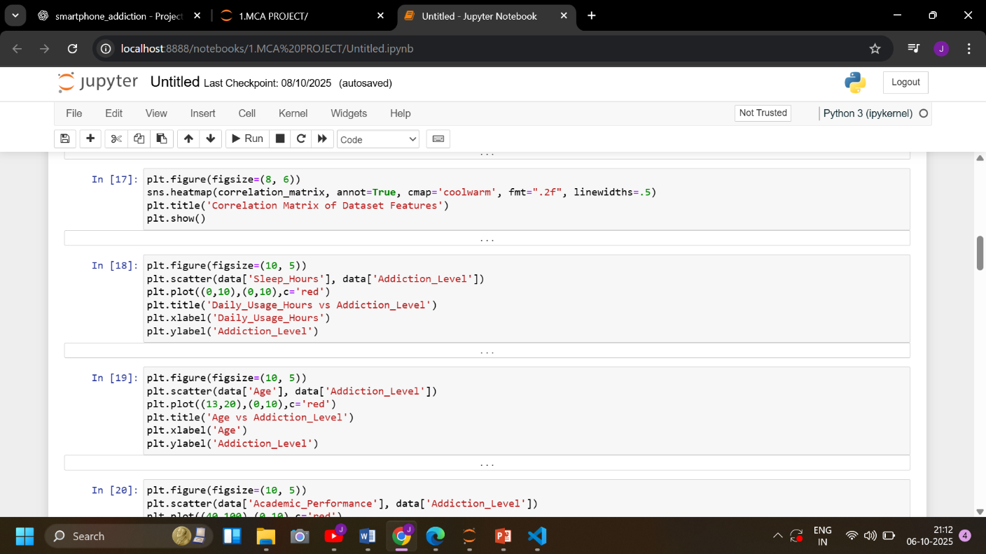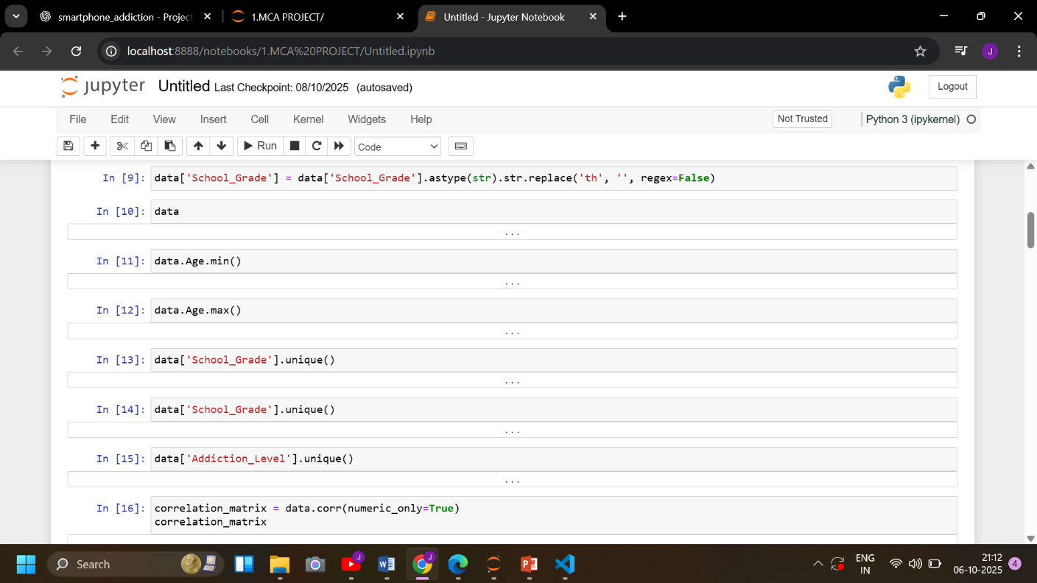

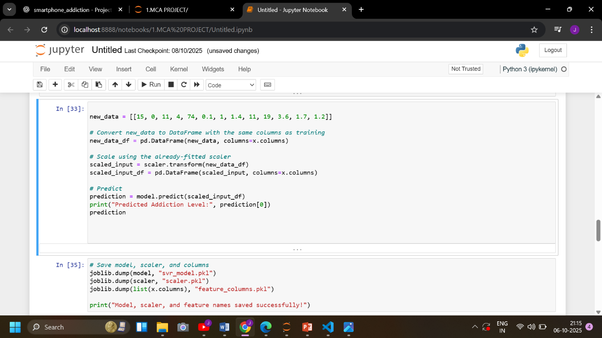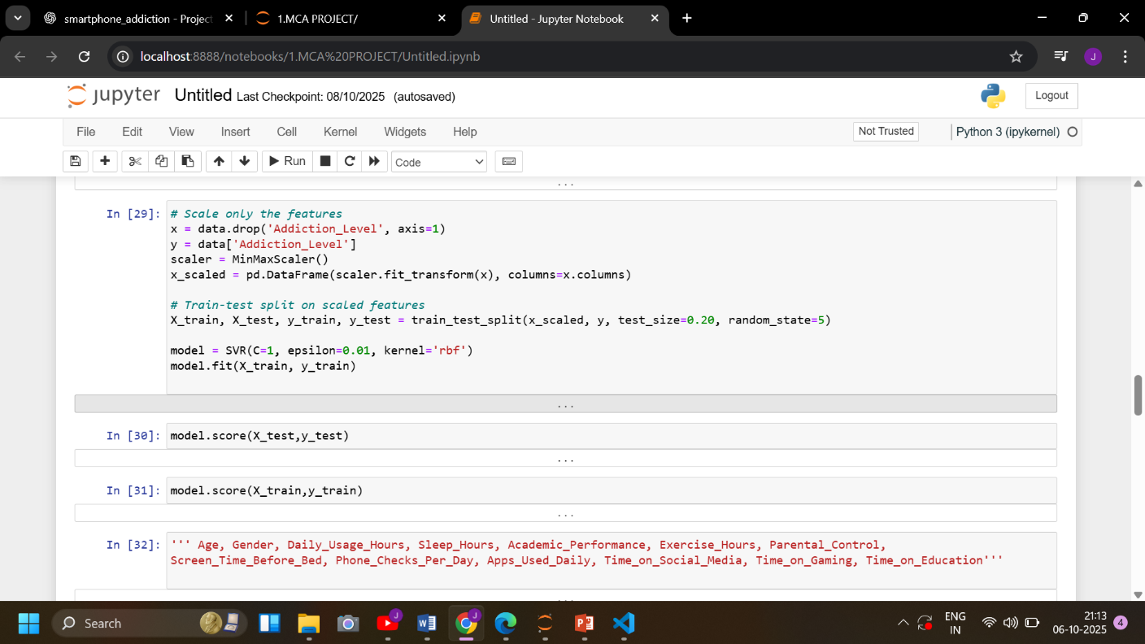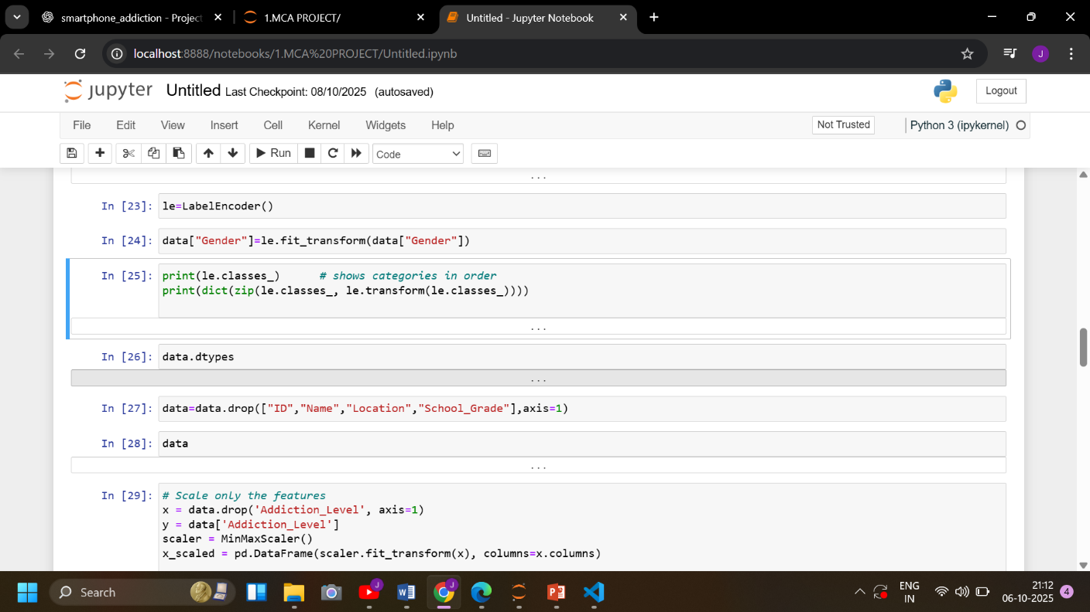

1. Screenshot

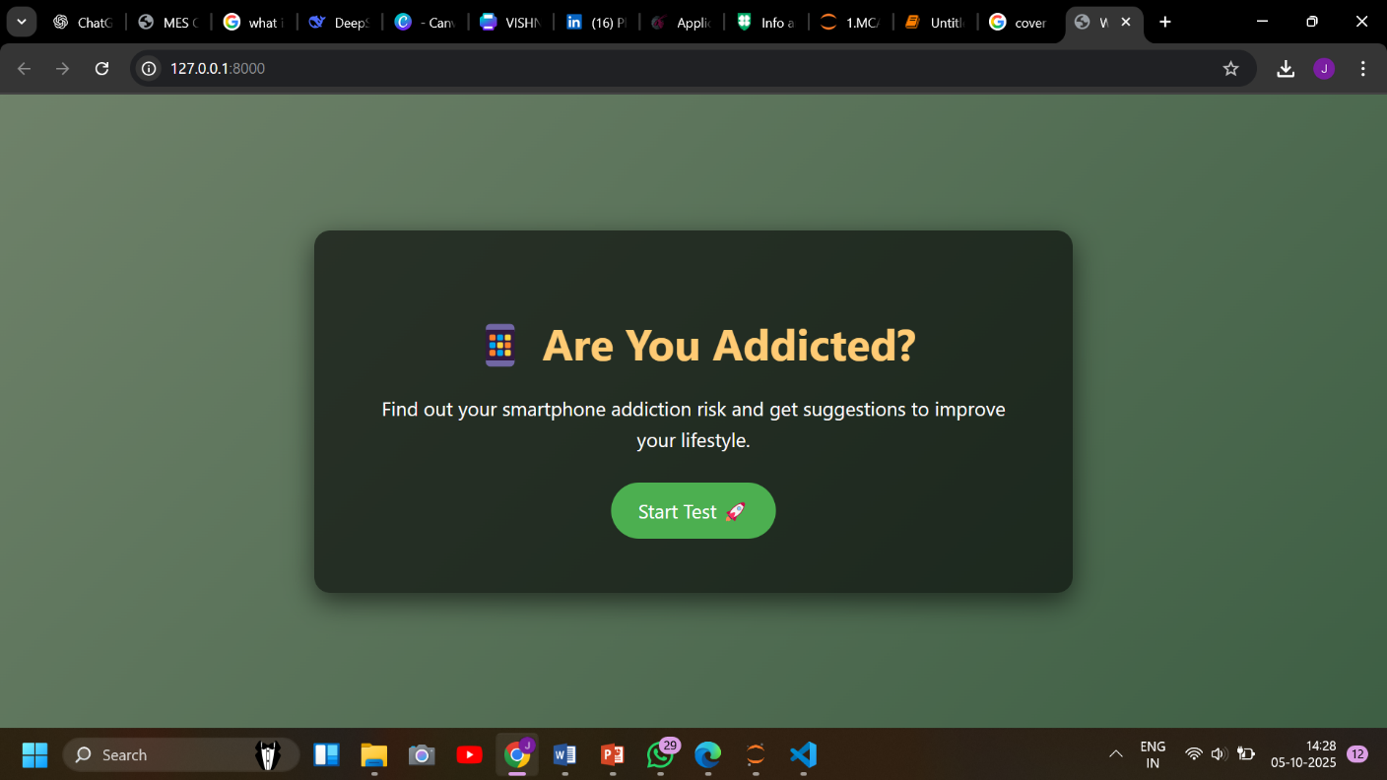Welcome page

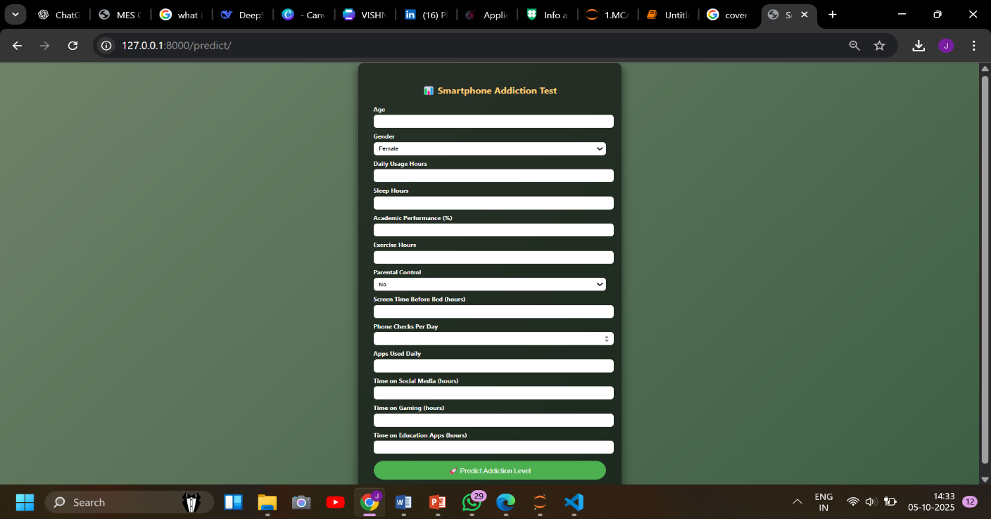Form Page

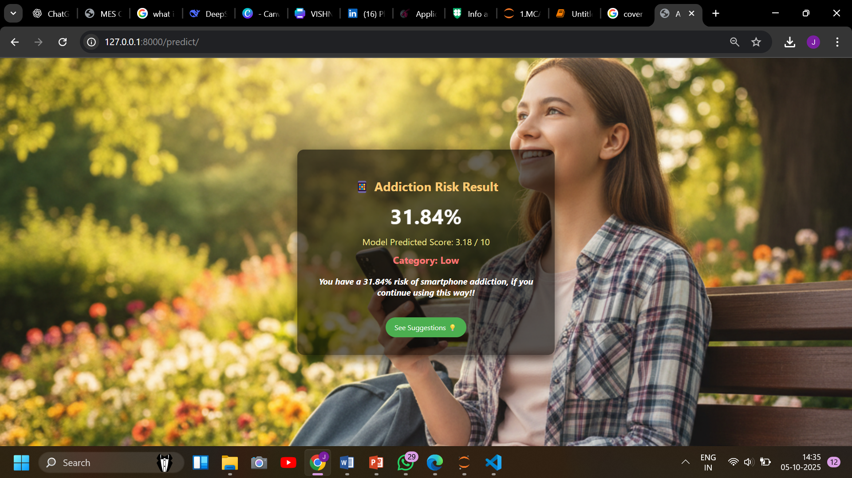Result Page

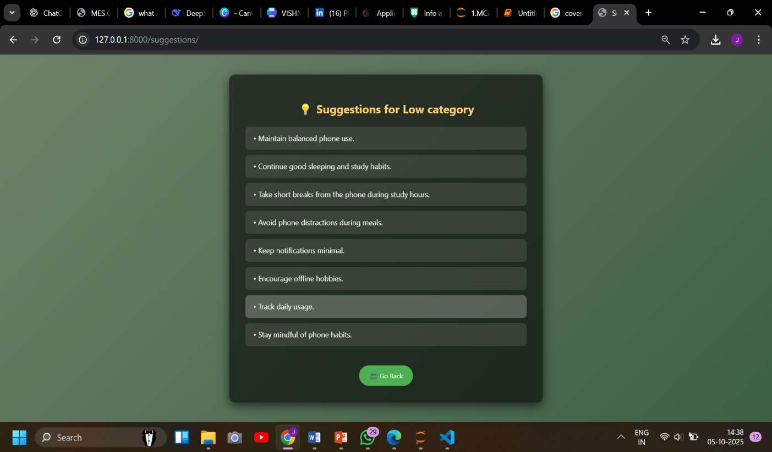Suggestion Page